

**LocAdoc**

**Database Design Document (DDD)**

**Version 0.1**

**Review Draft**

**Prepared by:**

**Abhi Jay Krishnan**

**Kim Hyeocheol**

**Rivaldo Erawan**

**Durrah Afshan**

Revision History

|  |  |  |  |
| --- | --- | --- | --- |
| **Date** | **Version** | **Description** | **Author** |
|  |  |  |  |
|  |  |  |  |

Table of Contents

1 Introduction 3

1.1 Document Objectives 3

1.2 Intended Audiences 3

1.3 References 3

1.4 Database Overview 3

1.5 Document Overview 3

2 Database-wide Design Decisions 3

2.1 Interfaces 3

2.2 Behavior 3

2.3 Appearance / Naming 3

2.4 DBMS Platform 3

2.5 Qualities 3

2.6 Distribution 3

2.7 Operations 3

2.8 Maintenance 3

3 Detailed Database Design 3

3.1 <design level> 3

3.1.1 <Name> Database 3

3.1.1.1 <Type> Logical Grouping 3

3.1.1.1.1 <Type> Field 3

4 Detailed Database Software Design 3

4.1 <Name> Software Component 3

5 Requirements Traceability 3

6 Notes 3

7 Appendices 3

**Table of Figures**

**Error! No table of figures entries found.**

# Introduction

The section introduces the Database Design Document (DDD) for LocAdoc to its readers.

## Document Objectives

This DDD for the LocAdoc software has the following objectives:

* Describe the design of a DynamoDB and SQLite database, that is, a collection of related data stored in one or more computerized files in a manner that can be accessed by users or computer programs via a database management system (DBMS). It can also describe the software units used to access or manipulate the data.
* To serve as the basis for implementing the database and related software units. It provides the acquirer visibility into the design and provides information needed for software support.
* All sections should remain in this document. If a section is to be tailored out, the section shall remain and contain the words “Tailored out”.

## Intended Audiences

This DDD is intended for the following audiences:

* Technical reviewers, Supervisor and UOW staff who must evaluate the quality of this document.
* LocAdoc developers including:

Architects, whose overall architecture must meet the requirements specified in this document.

Designers, whose design must meet the requirements specified in this document.

Programmers, whose software must implement the requirements specified in this document.

Testers, whose test cases must validate the requirements specified in this document.

## References

This DDD refers to the following references:

* <Application> Project Glossary
* <Application> Software Requirements Specification

## Database Overview

This database fills the following purposes:

* <General nature of the database>
* <Business context of database>
* <History of development>
* <Intended use>
* <Maintenance objectives>
* <Deployment locations>

## Document Overview

This DDD is organized into the following sections:

* *Introduction*, which introduces the database design for <Application> to its readers including referenced documents and an overview of the database including definition, business goals and context.
* *Database Overview*, which provides a high level description of the database including its definition, business goals, and context.
* *Database-wide design decisions,* which provides decisions about the databases behavioral design (how it will behave, from a user’s point of view, in meeting its requirements, ignoring internal implementation) and other decisions affecting further design of the database.
* *Detailed database design,* which will contain a section for each design level (conceptual, internal, logical, physical).
* *Detailed database software design,* scripts, data access components and management software.
* *Requirements traceability,* which provides traceability from the system or software requirements specification to the database software that implements it.
* *Notes,* which contains any general information that aids in understanding this document (e.g., background information, glossary, rationale). This section shall include an alphabetical listing of all acronyms, abbreviations, and their meanings as used in this document and a list of any terms and definitions needed to understand this document.
* *Appendices*, which may be used to provide information published separately for convenience in document maintenance.

# 

# Database-wide Design Decisions

This section documents decisions about the databases behavioral design (how it will behave, from a user’s point of view, in meeting its requirements, ignoring internal implementation) and other decisions affecting further design of the database.

## Interfaces

Design decisions regarding queries or other inputs the database will accept and outputs (displays, reports, messages, responses, etc.) it will produce, including interfaces with other systems and users.

## Behavior

Design decisions on database behavior in response to each input or query including actions, response times and other performance characteristics, selected equations / algorithms / rules, disposition, and handling of unallowed inputs.

## Appearance / Naming

Design decisions on how databases / files will appear to the user

## DBMS Platform

Design decisions on the database management system to be used (including name and version / release) and the type of flexibility to be built into the database for adapting to changing requirements.

## Qualities

Design decisions on the levels and types of availability, security, privacy and continuity of operations to be offered by the database

## Distribution

Design decisions on the database distribution (e.g., Client/server), master database file updates and maintenance, including and maintaining consistency, establishing / reestablishing maintaining synchronization, enforcing integrity and business rules.

## Operations

Design decisions on backup and restoration including data and process distribution strategies, permissible actions during backup and restoration, and special considerations for new or non-standard technologies such as video and sound.

## Maintenance

Design decisions on repacking, sorting, indexing, synchronization, and consistency including automated disk management and space reclamation considerations, optimizing strategies and considerations, storage and size considerations, and population of the database and capture of legacy data.

# Detailed Database Design

This section describes the actual design of different databases at varying levels of abstraction. A subsection for each of conceptual, internal, logical and physical levels.

## DynamoDB design (NoSQL database)

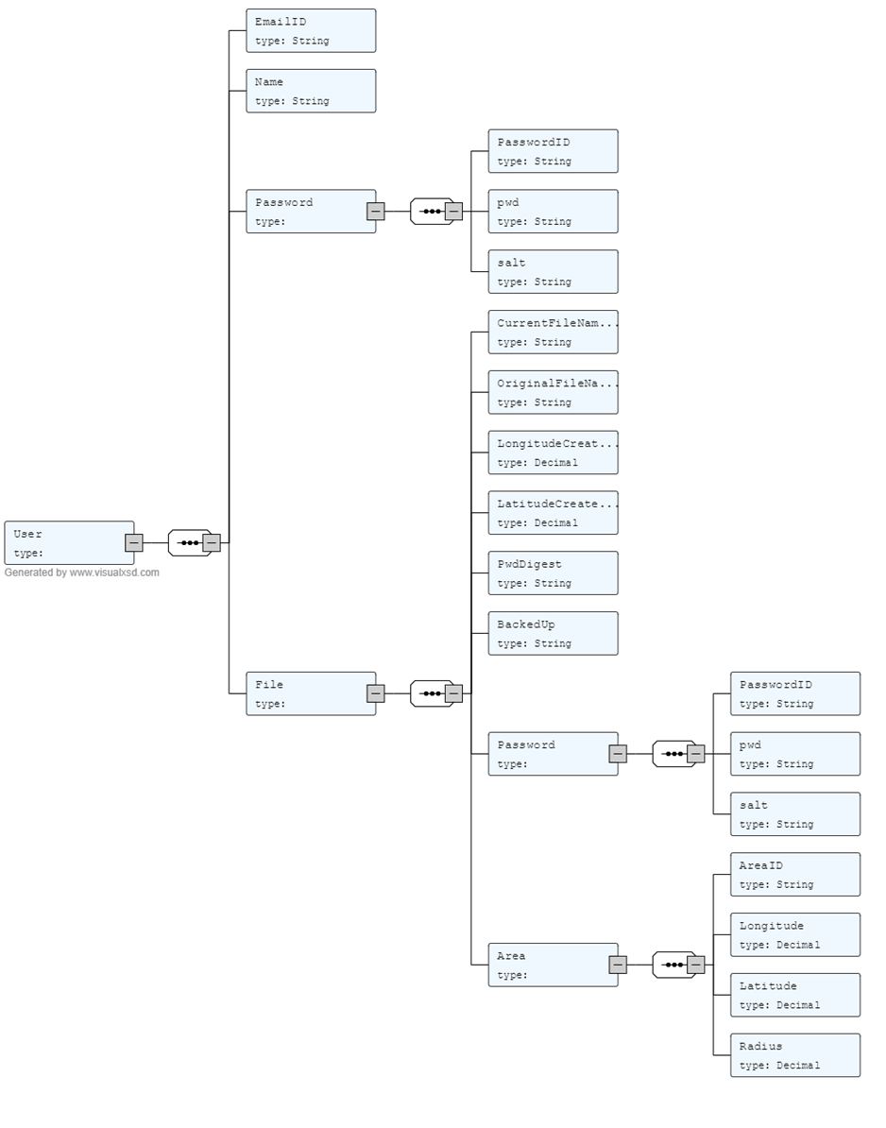

Figure 1: Database design

The diagram given above visualize the NoSQL database. This design was developed after creating a XML schema (Appendix 1) and using an online converter. [1]

### Object Diagram

Here is an object diagram to show a given instance of the database

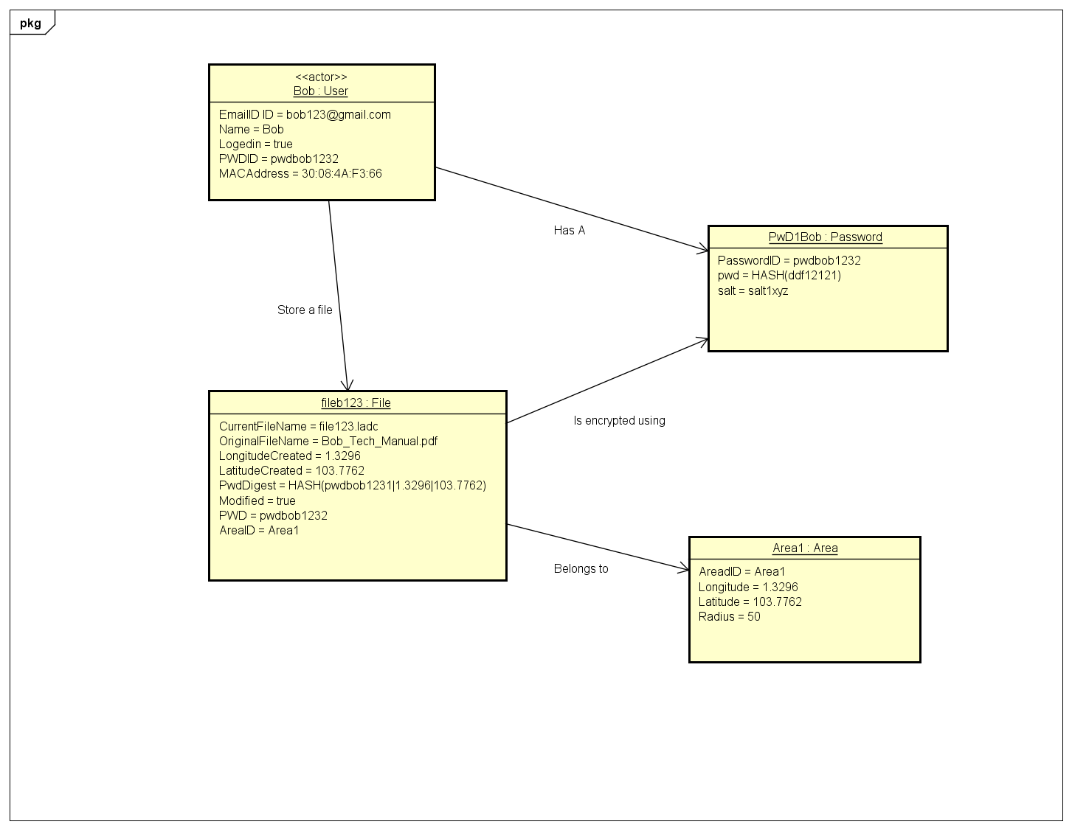

### Data dictionary

# Detailed Database Software Design

This section contains subsections for each software module used within the database. This includes but DynamoDB NoSQL database design and SQLite Relational database design.

## DynamoDB Design

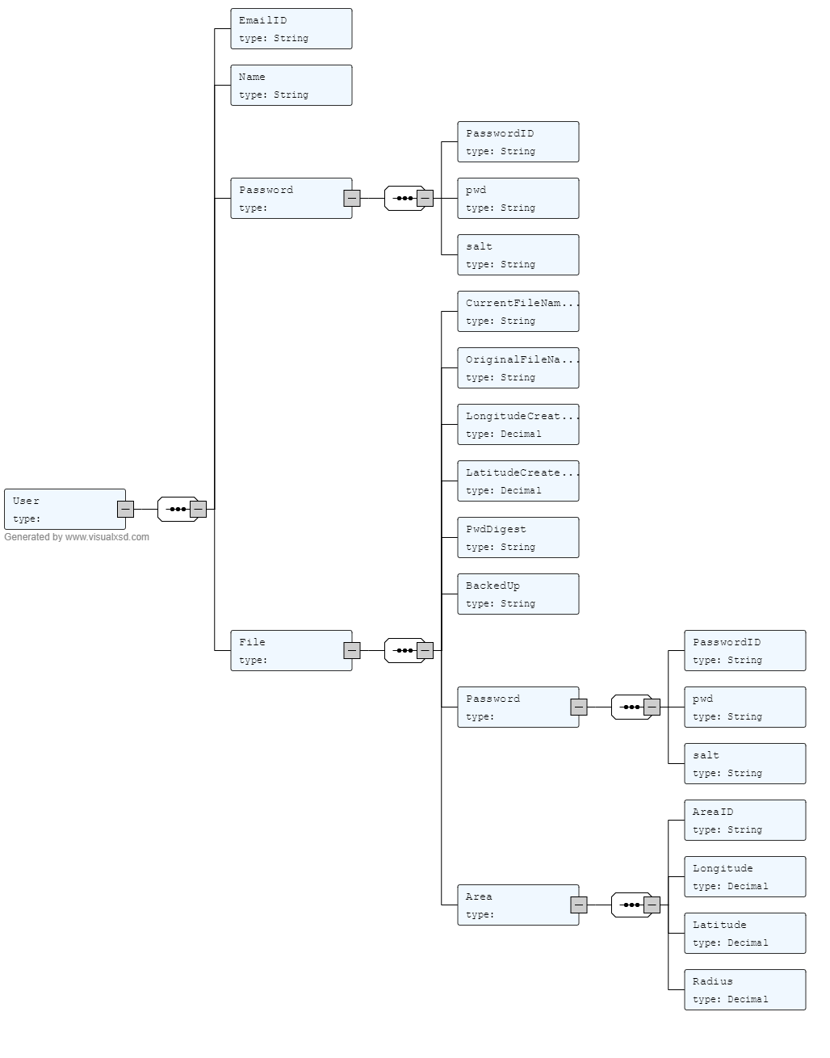

# Requirements Traceability

This section shall map each software component defined above in section 4 to a set of requirements stated in the SRS.

# Notes

This section shall any general information that aids in understanding this document (e.g., background information, glossary, rationale). This section shall include an alphabetical listing of all acronyms, abbreviations, and their meanings as used in this document and a list of any terms and definitions needed to understand this document.

# Appendices – XML Schema

This XML schema was created to check if the schema was well formed.



